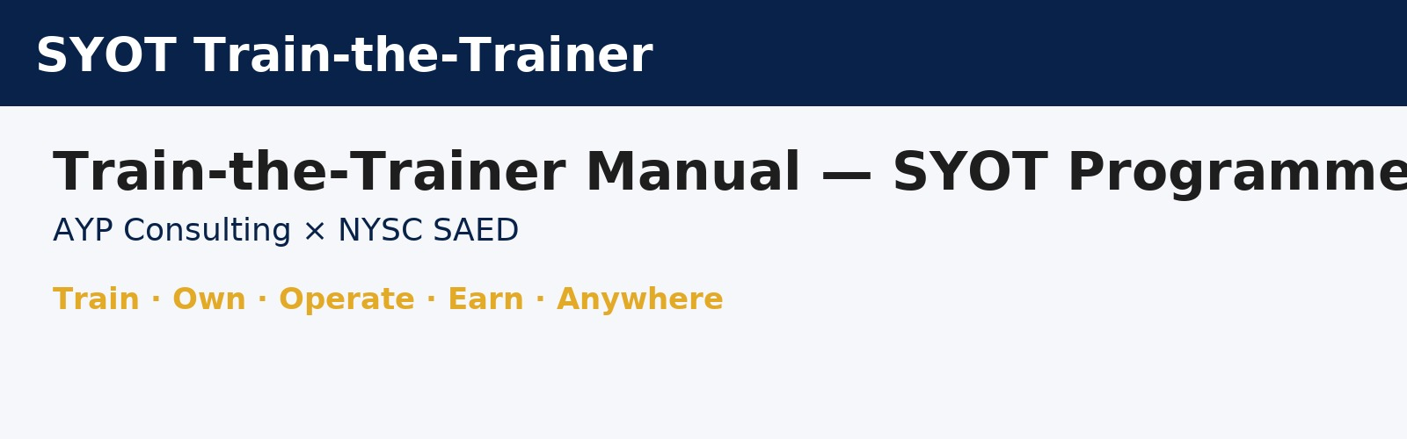
Version: 2025-10-06 · © 2025 AYP Consulting Limited | NYSC SAED | 9ja Travelhub

1. Project Overview
The Start-Your-Own-Travelpreneur (SYOT) Programme is a partnership between AYP Consulting Limited and NYSC SAED, supported by 9ja Travelhub and implementing partners. The programme will create 7,740 global remote Travelpreneur jobs by combining online training, instructor-led training (ILT), certification, and funding referrals to launch profitable Online Travel Agency (OTA) business portals.
- NYSC members (serving and ex-corps), graduates, women, migrants, and returnees.
- Diaspora investors supporting the Travelpreneur Investment Programme.

2. Implementation Process Flow (Official 7-Step Sequence)
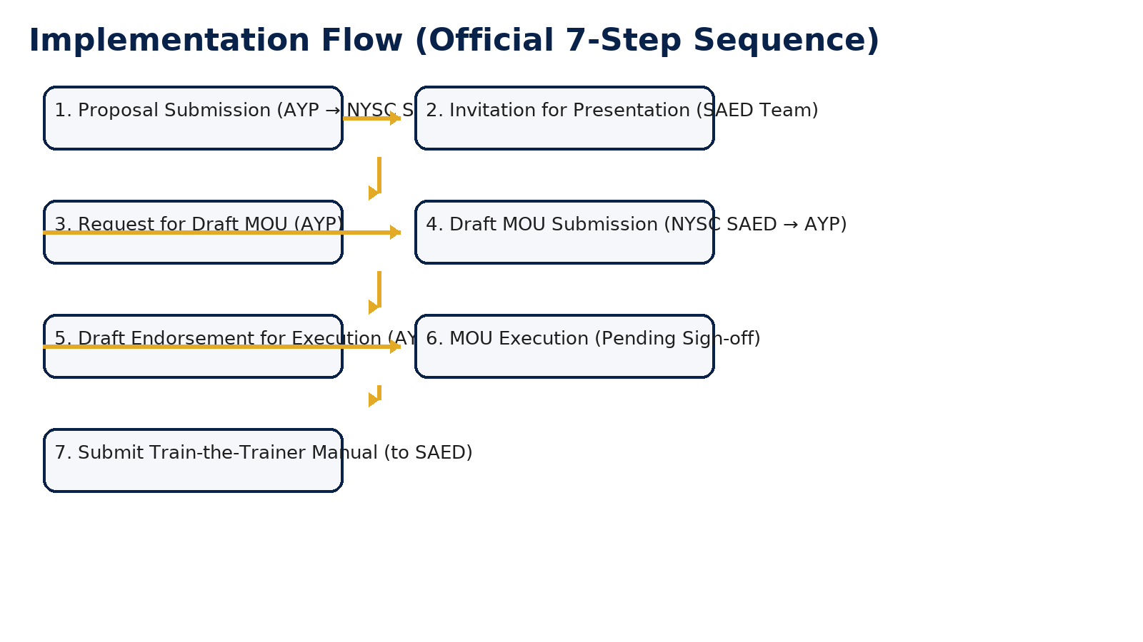
- 1. Proposal Submission (AYP → NYSC SAED)
- 2. Invitation for Presentation (SAED Team)
- 3. Request for Draft MOU (AYP)
- 4. Draft MOU Submission (NYSC SAED → AYP)
- 5. Draft Endorsement for Execution (AYP → SAED)
- 6. MOU Execution (Pending Sign-off)
- 7. Submit Train-the-Trainer Manual (to SAED)

3. Trainer Execution Phases (A–G)
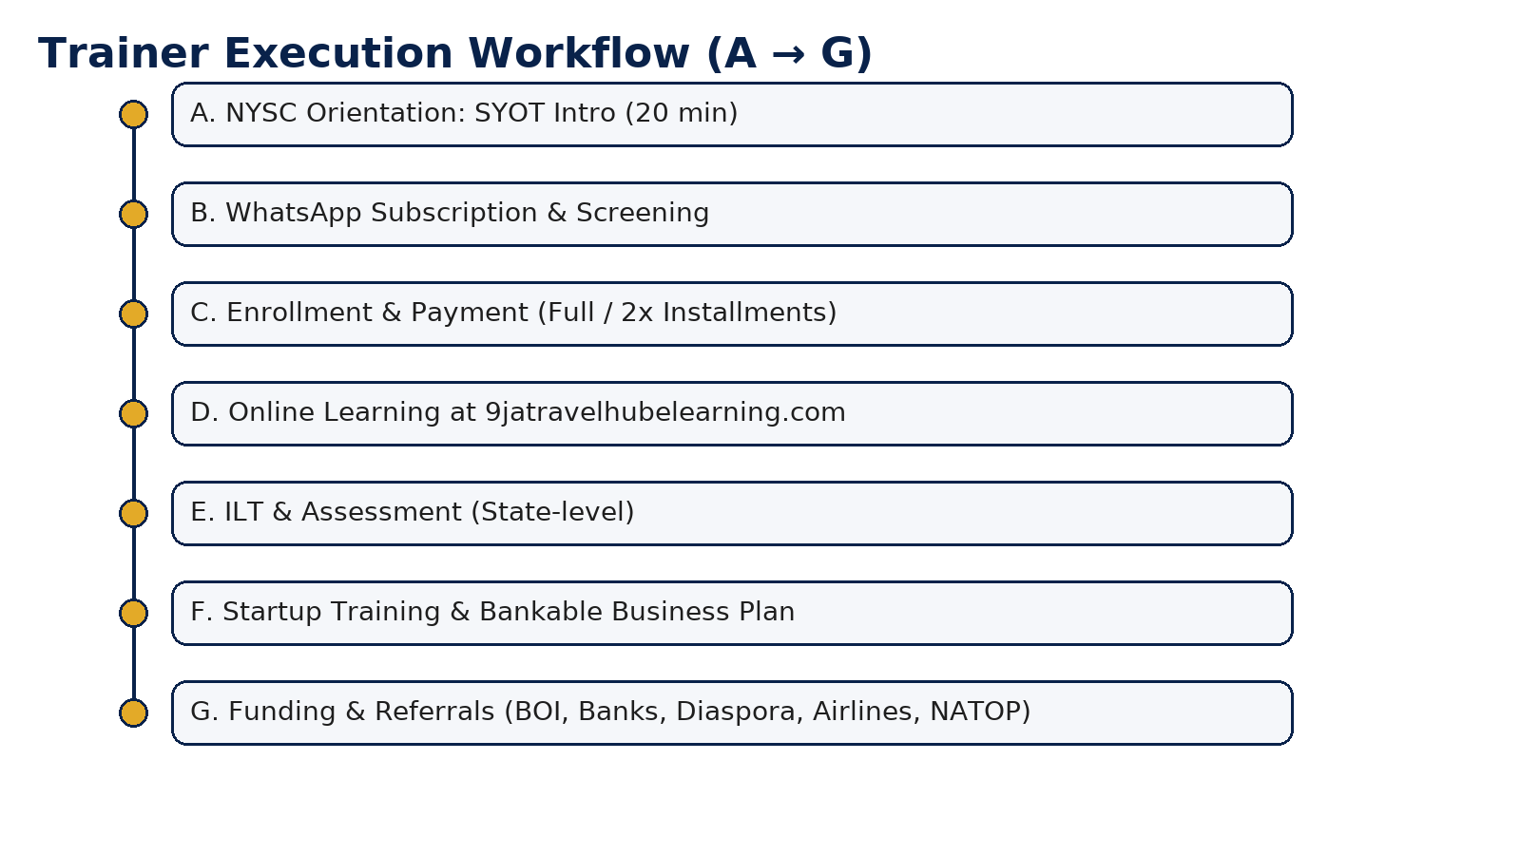

A. Orientation Camp Participation
- Deliver a 20-minute SAED session introducing the SYOT Programme.
- Display QR codes and WhatsApp links for registration.
- Collect lists of interested corps members with Name, State Code, Email, Phone.

B. WhatsApp Subscription & Screening
- Send approved welcome message and collect identity verification details.
- Screen for readiness and confirm interest and payment option.

C. Enrollment & Payment Options
- Provide enrollment link to https://9jatravelhubelearning.com.
- Share payment options: full or two equal installments.
- Verify receipts via Nominated Payment Collection Bank portal.

D. Online Learning Phase
- Issue credentials for the Virtual Learning Centre.
- Monitor module completion and assignment submissions.
- Provide weekly support via WhatsApp helpdesk.

E. Instructor-Led Training (ILT) & Assessment
- Schedule 1-day ILT cohort per state (virtual or hybrid).
- Conduct assessments via the Learning Portal or secure form.
- Publish pass/fail results and feedback.

F. Startup Training & Bankable Business Plan
- Use the standard SYOT business plan template.
- Validate unit economics and revenue projections.
- Prepare participants for funder-facing Q&A.

G. Funding & Referrals Pitch Presentation
- Guide trainees to pitch to BOI, Payment Banks, Diaspora investors.
- Engage airlines, NATOP, and private sector allies for partnerships.
- Track outcomes and update referral logs.

4. Sample WhatsApp Enrollment Script
Hello 👋! Welcome to the Start-Your-Own-Travelpreneur (SYOT) Programme in partnership with NYSC SAED and AYP Consulting.
Please reply with your details:
• Full Name
• State Code / Call-Up No.
• Email Address
• Preferred Payment Option (Full / 2 Installments)
You’ll receive your enrollment link and training instructions within 24 hours.

5. Platforms & Contacts
Training Portal: https://9jatravelhubelearning.com
SYOT Business Portal: https://9jatravelhub.online
Support Email: info@9jatravelhub.online
WhatsApp Helpline: +234-803-661-7598

6. Branding & Implementing Partners
Header: AYP Consulting Limited × NYSC SAED
Footer (Implementing Partners): AYP Hosted Solutions, 9ja Travelhub (Online & International), Nigerian Banks (Payment Collection), Traveloka, 9ja Musicpreneurs Hub, Nigeria Telcos.

